**Software Engineering Tools Lab Assignment No-4**

(Module 3- GitHub) **Due date-24/02/2023**

Q 1. Create a repository on GitHub named SET Lab and add files into it (you can add implementation files of previous assignment) perform below operations on it. (Add screenshot as an answer to every question)

1. Perform commit on added files

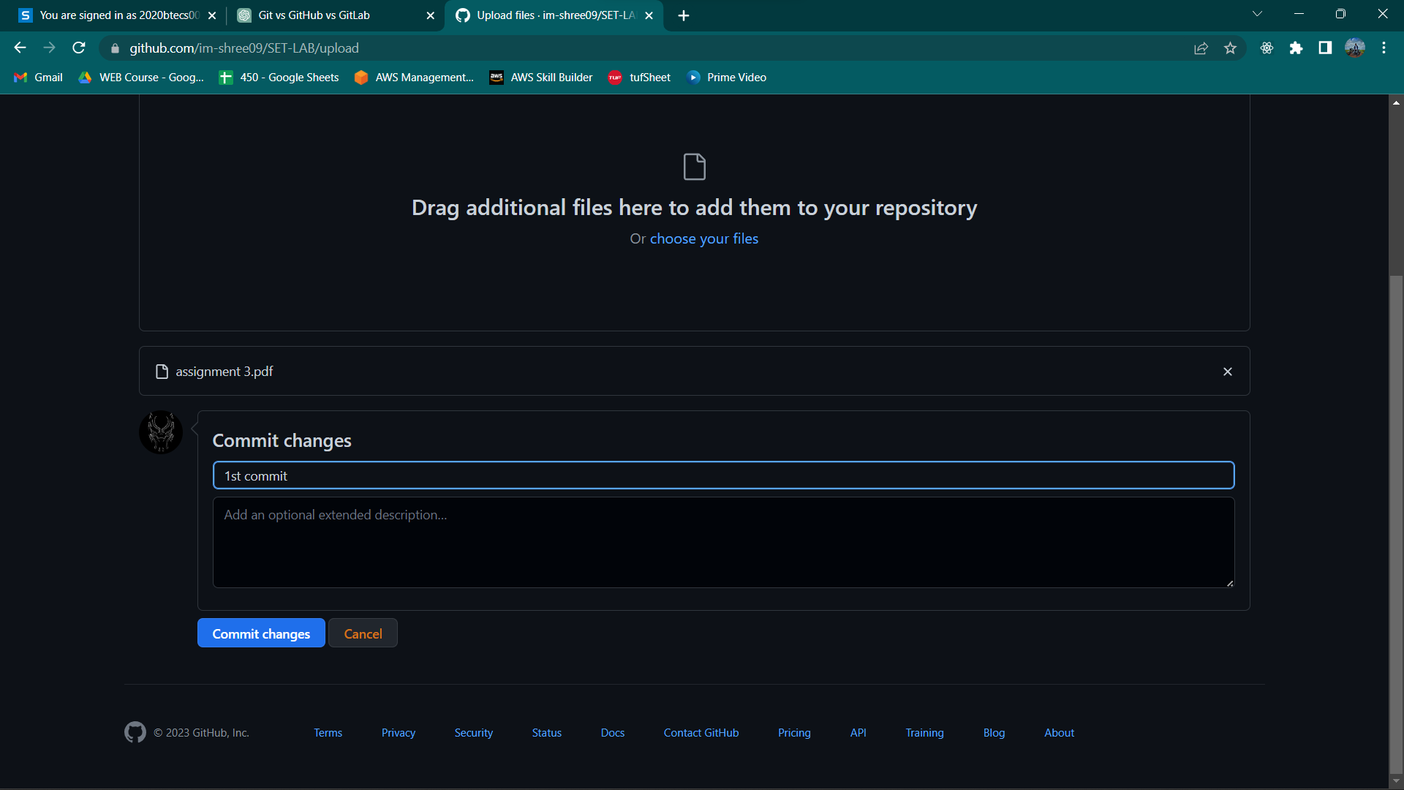

1. Perform update to the existing files (show history)

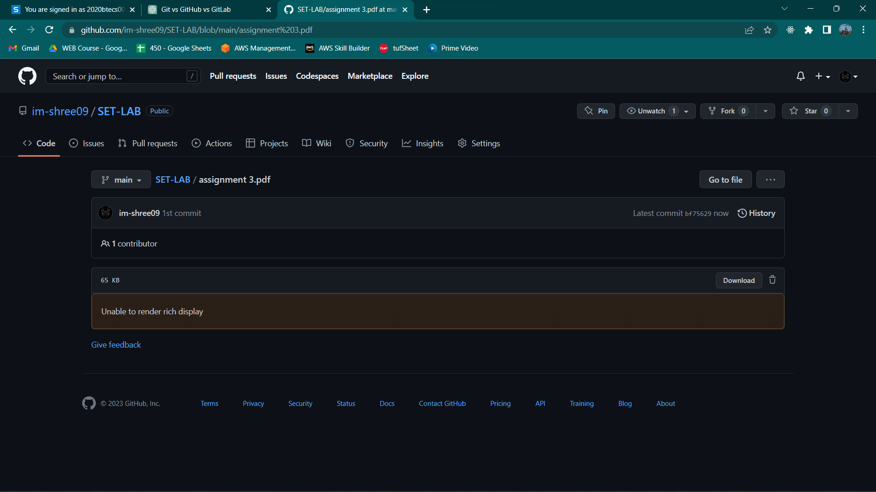

1. Create another branch

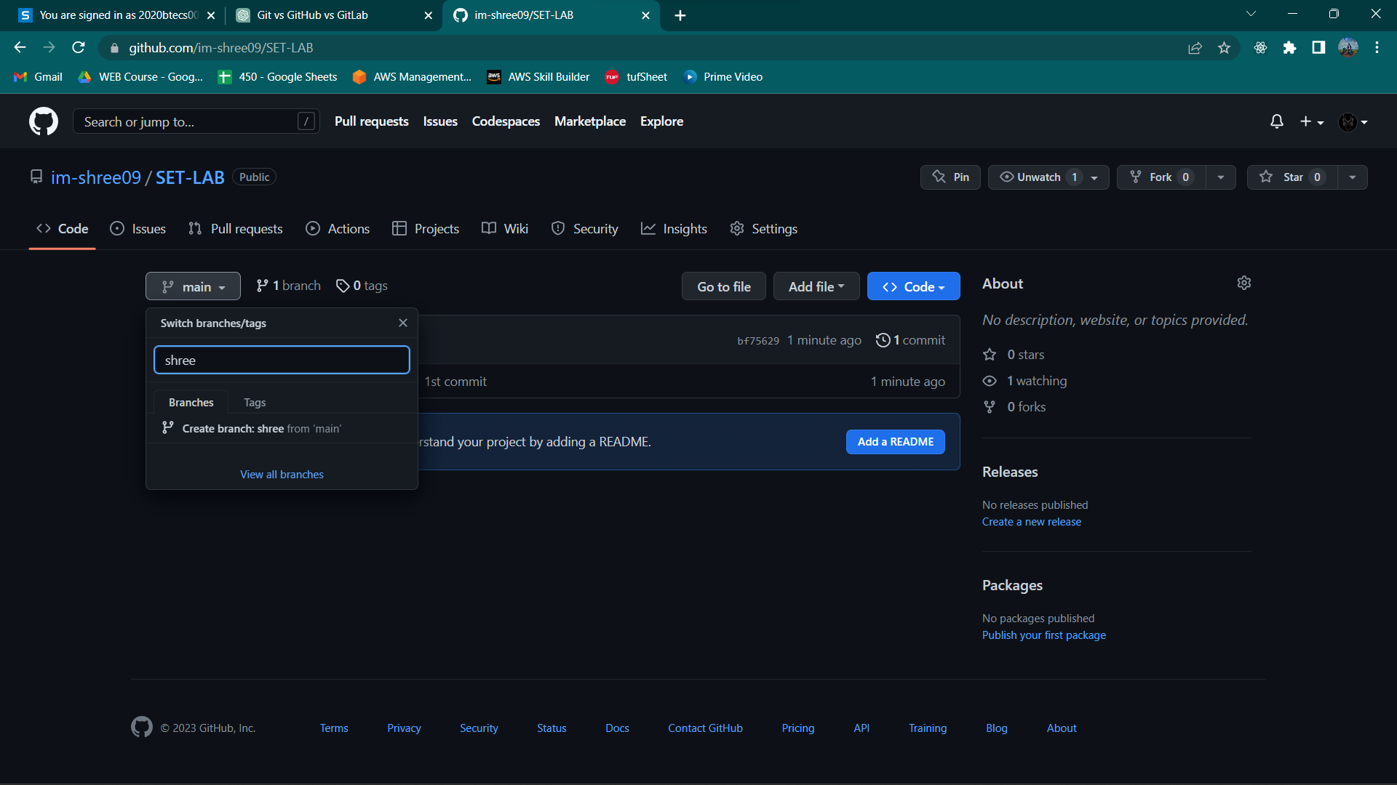

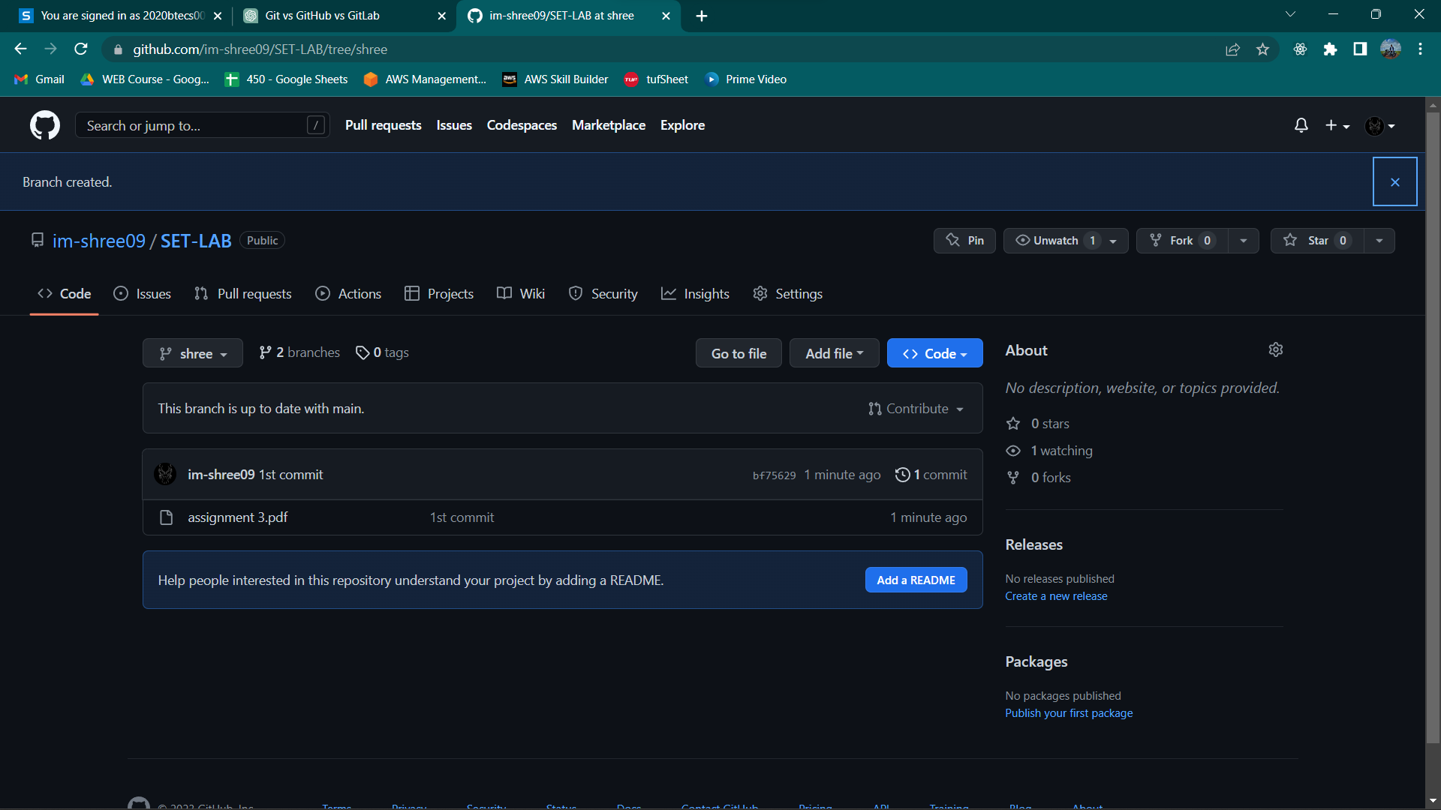

1. Create pull request

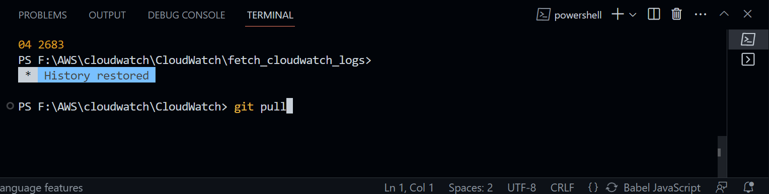

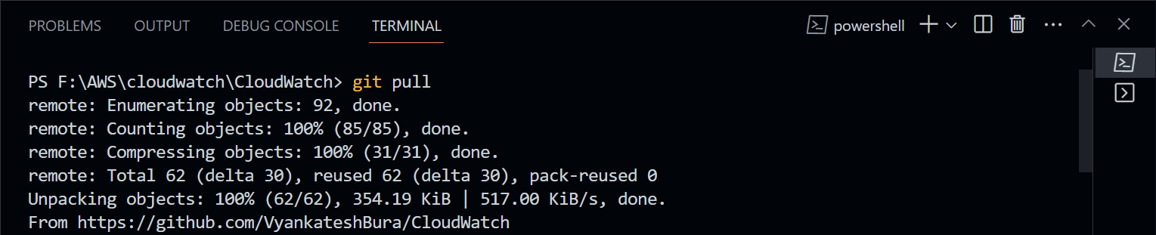

1. Perform merging of both branches
2. Perform Fork operation

Q 2. For the diagram given below create a GitHub repository and perform operations given in the diagram. (Perform commit operations as given)(Add screenshots as an answer to this question)

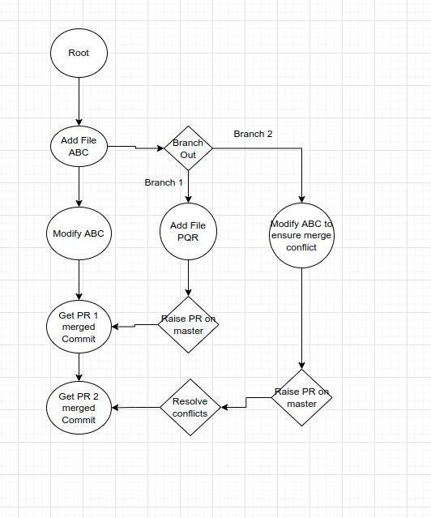

Q 3. What is GitHub desktop? How to install GitHub on local machine? Install GitHub on your local machine and access repository created in question no 1 (add screenshots).

GitHub Desktop is a graphical user interface (GUI) for managing Git repositories. It provides an easy-to-use interface for creating and managing repositories, committing changes, branching and merging, and collaborating with others.

To install GitHub Desktop on your local machine, follow these steps:

Go to the GitHub Desktop download page at https://desktop.github.com/.

Click the "Download for [your operating system]" button.

Once the download is complete, open the installer and follow the on-screen instructions to install GitHub Desktop on your local machine.

Here are the steps to access a repository on GitHub Desktop:

Open GitHub Desktop and sign in to your GitHub account.

Click the "Add" button in the top left corner and select "Clone Repository".

In the "Clone a Repository" window, select the "URL" tab.

In the "Repository URL" field, enter the URL of the repository you want to clone. You can copy the URL of the repository from the browser address bar.

Choose the local path where you want to save the repository.

Click the "Clone" button to clone the repository.

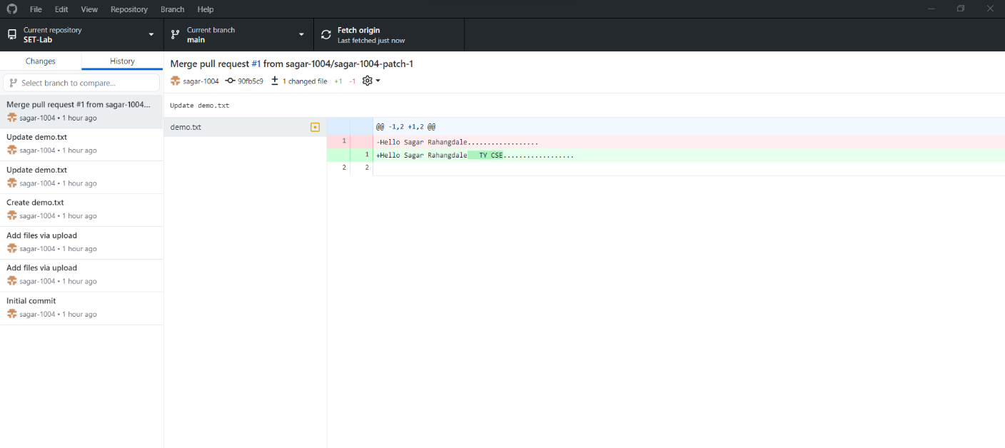

Q 4. Differentiate in between GitHub, Git and GitLab.

1. Git: Git is a distributed version control system that allows you to track changes to code over time. It is a command-line tool that you can use locally on your computer to manage your code changes. With Git, you can create branches, merge changes, revert changes, and collaborate with other developers.
2. GitHub: GitHub is a web-based platform that hosts Git repositories. It provides a graphical user interface for managing Git repositories, as well as a social network for developers to collaborate and share code. You can use GitHub to host your Git repositories, manage your code changes, and collaborate with others on your code.
3. GitLab: GitLab is a web-based Git repository manager that provides a similar set of features to GitHub. It also provides additional tools for continuous integration and deployment, issue tracking, and project management. GitLab can be installed on your own server or used as a hosted service.

Q 5. What is version control? Explain with example.

Version control is a system that records changes to a file or set of files over time so that you can recall specific versions later. It is a tool that allows you to track the history of changes to your code or other files, and to collaborate with other developers on those changes.

A common example of version control is using Git to manage the code for a software project. With Git, each time you make changes to your code, you create a new version of the code that is stored in a repository. This allows you to see a history of changes to the code over time, as well as who made those changes and when they were made.